Case Study 1:
Creating a New Process using fork()
#include <stdio.h>
#include <unistd.h>

int main() {
printf("Before fork\n");

fork();

printf("Process ID: %d\n", getpid());

return 0;
}
Execution:
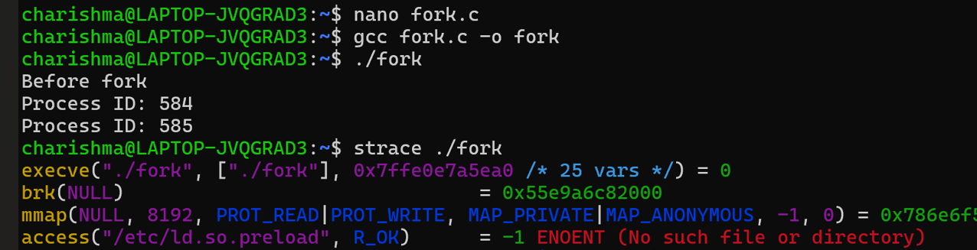
Output:
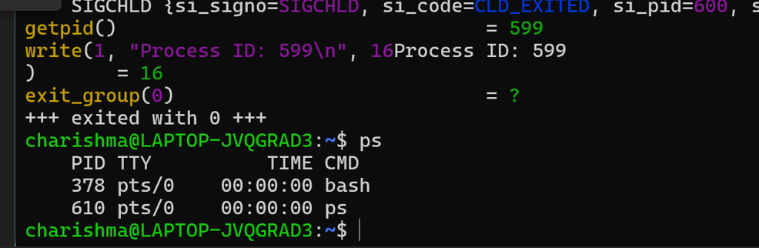
Result:
fork() successfully created a child process

